10-05
Praneeth M V L S S S
1NT19IS112

BIG DATA -04

Map reduce
1)
> var map = function() {emit(this.name,this.salary);};
> db.praneeth.mapReduce( map, reduce, {out:"totals"});
{ "result" : "totals", "ok" : 1 }
> db.totals.find()



2) Total salary based on dept
var map = function() {emit(this.dept,this.salary);};
> var reduce = function(dept,salary) {return Array.sum(salary);};
> db.praneeth.mapReduce( map, reduce, {out:"totals"});
{ "result" : "totals", "ok" : 1 }
> db.totals.find()

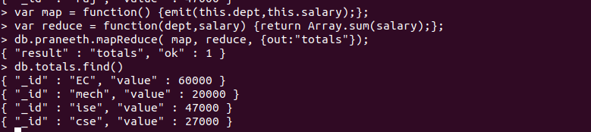

3) Avg salary based on dept
var map = function() {emit(this.dept,this.salary);};
> var reduce = function(dept,salary) {return Array.avg(salary);};
> db.praneeth.mapReduce( map, reduce, {out:"totals"});
{ "result" : "totals", "ok" : 1 }
> db.totals.find()

